Current Electricity

---
# RC circuit, ladder circuit, multiplier circuit karna h
---
⎚ Topic Overview
* Significance: Current Electricity is a high-frequency chapter for both JEE Main and Advanced. It bridges the gap between Electrostatics (stationary charges) and Magnetism (moving charges).
* Syllabus Fit: It follows Electrostatics and Capacitance. Note that RC Circuits (Resistor-Capacitor) are typically covered during the Capacitance chapter, so these notes focus on pure resistive networks and measuring instruments.
* Relevance: Historically, this chapter provides a significant percentage of questions in the Physics section. Mastery of "Nodal Analysis" and "Symmetry" is essential for solving Advanced-level problems quickly.
# I = neA(v_d) {N-A-V-E-D} v_d = (eEτ/m) #

⎚ Fundamentals: Electric Current (I)
■ Core Intuition & Concept Building
* Definition: Current is the rate of flow of charge through a cross-section
(I = dq/dt).
* The Scalar Nature: Although current has a specific direction (flow of positive charge), it is a scalar quantity. This is because current does not follow the laws of vector addition (e.g., if two wires meet at an angle, the net current is simply the algebraic sum, not a vector resultant).
* Physical Meaning: It is a fundamental quantity in the SI system.

■ Detailed Concepts & Analysis
* Average vs. Instantaneous Current:
* Instantaneous (I_{inst}): The current at a specific moment, found by differentiating charge: I = dQ/dt.
* Average (I_{avg}): The total charge flown over a total time interval: I_{avg} = ΔQ/ΔT or ∫(I)dt/∫dt.
* Graphical Interpretation:
* Charge vs. Time (Q-t) Graph: The slope at any point gives the instantaneous current (I).
* Current vs. Time (I-t) Graph: The area under the curve represents the total charge (Δ Q) flown during that interval.

⎚ Microscopic View: Drift Velocity & Ohm’s Law
■ Core Intuition
* Carrier Density (n): Defined as the number of free electrons per unit volume. It is a material-dependent property. Caution!: Do not confuse this with the total number of electrons; only "free" electrons contribute to conduction.
n = (no. of free electrons)/Volume

* The "Random Motion" vs. "Drift" Model:
* No Battery: Electrons move randomly due to thermal energy (10^5 to 10^6 m/s), but their average velocity is zero. No net current flows.
* With Battery: An electric field (E) is established. Electrons still move randomly but now experience a small "drift" opposite to E.

* Relaxation Time (τ): The average time between two successive collisions of an electron with the lattice ions.

■ Detailed Concepts
* Drift Velocity (v_d): The average velocity with which electrons drift toward the positive terminal.
* Formula: v_d = (eE / m) τ.
* Key Insight: Here, m is the mass of the electron, not the mass of the conductor.
# e = charge on 1 electron , E = electric field across conductor
# m = mass of 1 electron , tau = mean relaxatation time
{v = at, yaha e pe force eE laga (F = qE) aur a = F/m toh acceleration aaya eE/m aur time ki jagah tau rakh diya, // ye sirf yad karne ke liye h :)}

* Mobility (μ): Defined as the drift velocity attained per unit electric field (μ = v_d / E).
* Formula: μ = eτ / m.
* Mental Model: Lighter particles or those with fewer collisions (higher τ) are more "mobile".

⎚ Resistance (R) and Resistivity (ρ)

■ Derivation Logic (Microscopic to Macroscopic)
By combining I = neA(v_d) {N-A-V-E-D}, Electric field= Voltage/length {E = V/l} and v_d = (eEτ/m), we derive the microscopic version of Ohm's Law:
I = neA(eEτ/m) = [n(e^2)Aτ/ml]V {∴V/R = I}
R = (ml/n(e^2)τA) {∴R = ρl/A}
ρ = m/n(e^2)τ {∴ m and e are constants}
ρ ∝ 1/n(τ)
# slope of V-I graph is R

G = 1/R {G = conductance}
σ = 1/ρ {ρ = conductivity}

■ The Resistance Formula
R = ρ (L / A), where ρ = m / (ne^2τ).
* Resistance (R): Depends on ”geometry” (Length L, Area A), temperature and nature of material.
* Resistivity (ρ): Depends ONLY on the nature of the material and temperature. It is independent of length and area.

■ Temperature Dependence
* Conductors: As Temperature (T) ↑, thermal vibrations ↑, causing more frequent collisions. Thus, ”Relaxation Time (τ) ↓”, which leads to Resistivity (ρ) ↑.
# temperature ↑ ⇒ thermal vibrations ↑ ⇒ collisions ↑ ⇒ relaxation time ↓ ⇒ ρ ↑ ⇒ R ↑

* Formula: R = Rₒ(1 + ∝ΔT).
* ∝ (Thermal Coefficient): The fractional change in resistance per unit temperature. It is material dependent and positive for conductors.
∝= ΔR/Rₒ(ΔT)
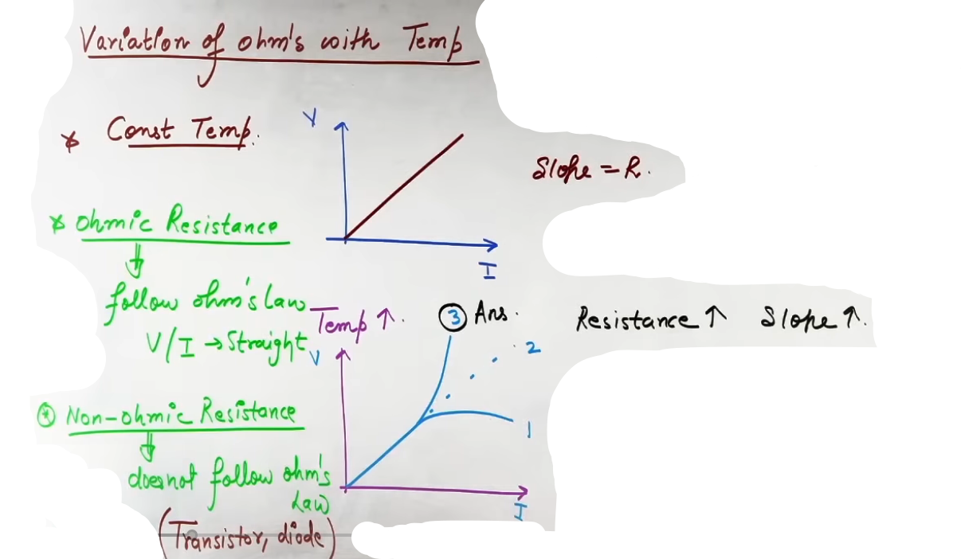
# R = Rₒ(1 + ∝ΔT) OR R = Rₒ + Rₒ∝ΔT {y = c +mx}

# ohmic resistance, non-ohmic resistance

* Semiconductors: As T ↑, more electron-hole pairs are created, causing “Carrier Density (n) ↑”. Even though τ decreases, the increase in n dominates. Result: Resistance ↓ as T ↑.

---

⎚ Geometry-Based Resistance (Calculus Applications)
JEE Advanced frequently tests resistance in non-standard shapes where L or A varies.

# isotropic (ρ = constant)
# anisotropic (ρ = vary {integration} )

R = ρL/A
L (Length): The distance traveled “by the current”.
A (Area): The cross-sectional area “perpendicular” to the flow of current.

■ Special Cases:
1. Hollow Concentric Spheres (Radius a to b): Current flows radially. We take a spherical shell of radius r and thickness dr.
* dR = ρ dr / (4π r^2).
* Integrating from a to b gives R = (ρ / 4π)(1/a - 1/b).
2. Concentric Cylinders (Length L, Radius a to b): Current flows radially outwards.
* dR = ρ dr / (2π r L).
* Integrating gives R = (ρ / 2πL) ln(b/a).

⎚ Current Density (𝐉) and Vector Ohm's Law
* Current Density (𝐉): Current per unit area (𝐉 = I/𝐀). It is a vector pointing in the direction of current. {𝐉⋅𝐀 = I}
I = neA(v_d)
I/A = ne(v_d)
J = ne(v_d)
J = ne(eEτ/m)
𝐉 = (n(e^2)τ/m)𝐄
𝐉 = σ𝐄 # vector form of ohm's law

* Vector Form of Ohm’s Law: 𝐉 = σ𝐄, where σ = 1/ρ is conductivity. This is also known as the ”Microscopic Ohm's Law”.
-------------------------------------------------------------------------------
# Jaise fluids m tha eqn of continuity, A₁v₁ = A₂v₂, dv/dt = constant (rate of flow), vaise hi yaha rate of flow of electron constant hoga toh jahan resister m area jyada waha drift velocity kam and vice-versa.
v_d ∝ 1/Area
Current conductor se pass karta h usme store nahi hota to jitne electron enter huye utne exit honge {I=constant}
J = I/A ⇒ J ∝1/A
-------------------------------------------------------------------------------

⎚ Stretched Wire Logic
* Constraint: When a wire is stretched, its ”Volume remains constant” (V=AL).
* Pattern: If length becomes n times (L' = nL), the area must become 1/n times (A' = A/n).
* Result: Resistance becomes n^2 times (R' = n^2 R).

⎚ Summary Formula Sheet
Concept | Formula | Key Terms
Current | I = dq/dt = n e / t | n = number of flowing electrons
Drift Velocity | v_d = (eEτ/m) | τ = relaxation time, m = mass of e⁻
Current (Micro) | I = neAv_d | "NEAVD" or "VENA"
Resistivity | ρ = m / (ne²τ) | Independent of L, A
Temp Effect | R = Rₒ(1 + ∝Δ T) | Rₒ is at °C or initial temp
Current Density | J = I/A = σE | Vector quantity

Colour coding of carbon resistor-
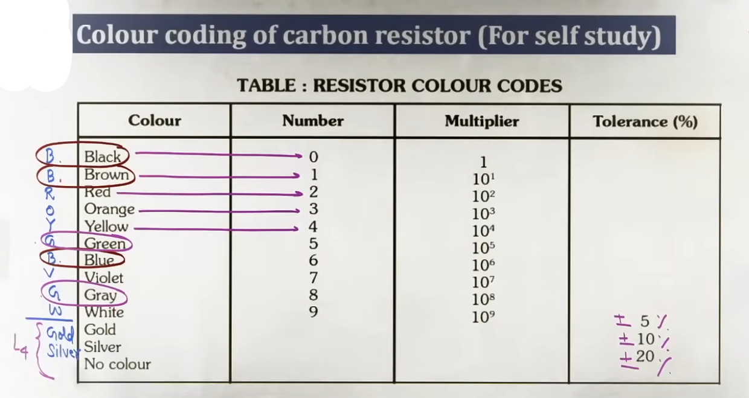
resistance = _ _ x _ ± _
L1 L2 L3 L4

⎚ Kirchhoff’s Laws: The Foundation of Circuitry
There are two laws given by Kirchhoff for determination of potential difference and current in different branches of any complicated network.

■ Core Intuition & Concept Building
* Kirchhoff’s Current Law (KCL / Junction Law/ First law):
* Logic: Based on the ”Conservation of Charge”.
* Meaning: Charge cannot accumulate at a junction. The total current entering a junction must equal the total current leaving it (∑ Iᵢₙ = ∑ Iₒᵤₜ).
Iᵢₙ = Iₒᵤₜ

* Kirchhoff’s Voltage Law (KVL / Loop Law/ Second law):
* Logic: Based on the ”Conservation of Energy”.
* Meaning: In a closed loop, the algebraic sum of all potential changes (drops and gains) must be zero (∑ΔV = 0).

■ Detailed Concepts: Sign Conventions (The "Rulebook")
To apply KVL without errors, follow these fixed conventions:
* Batteries: The sign depends ONLY on the terminal from which your path exits.
* Exit through Positive terminal : +E.
* Exit through Negative terminal : -E.
* Resistors: The sign depends on the direction of your path relative to the current.
* Path in the direction of current : -IR (Potential drop).
* Path opposite to current : +IR (Potential gain).
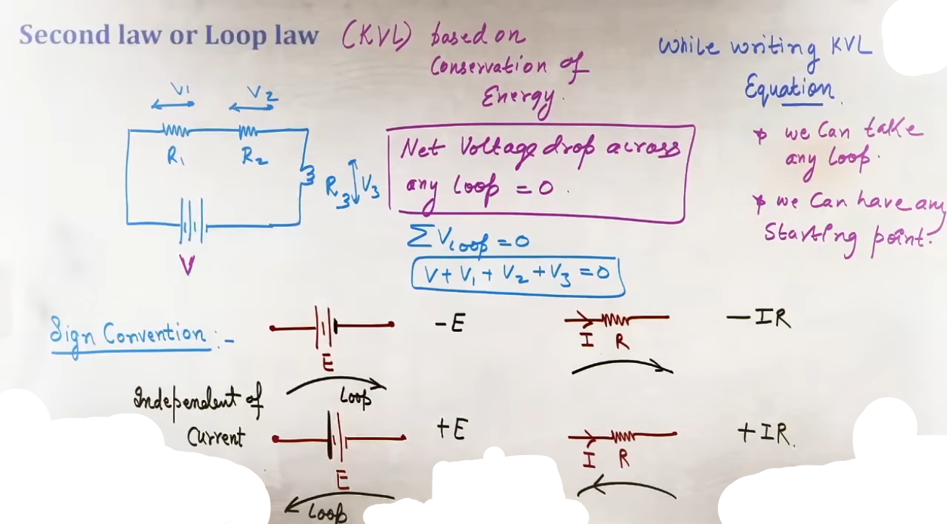
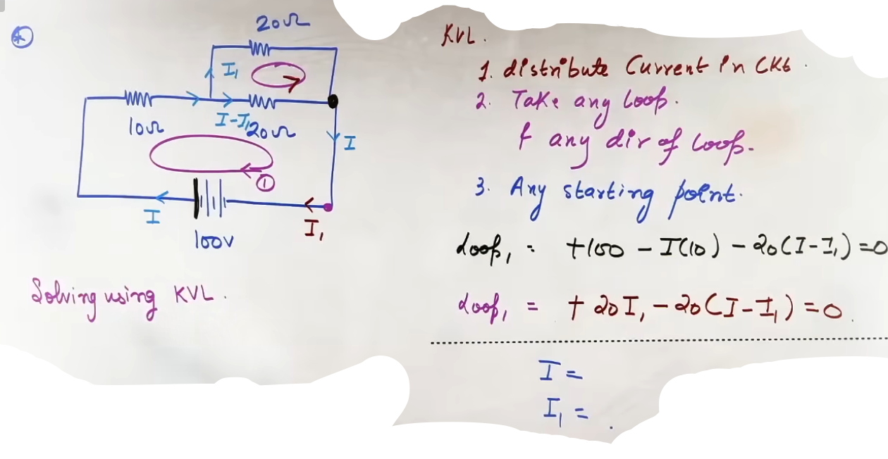

⎚ Advanced Technique: Nodal Analysis

■ Core Intuition
Nodal analysis is often significantly faster than KVL for complex circuits with many loops. Instead of loop currents, it focuses on ”Node Potentials”.

■ The Procedure
1. Select a Reference Node: Choose a junction (ideally near the negative terminal of the main battery) and assign it a potential of 0V.
2. Assign Potentials: Move across batteries from the reference node to assign potentials to other junctions (e.g., crossing a 10V battery {from the negative to positive side} from the 0V side makes the next node 10V).
3. Define Unknowns: If a node's potential cannot be determined directly, call it x.
4. Apply KCL at Node x: Assume x is the highest potential. Write the current leaving through every branch:
* ∑ I = 0 → {x - V_1}/{R_1} + {x - V_2}/{R_2} + ... = 0.
5. Solve for x: Once x is known, the current in any branch is simply the potential difference divided by that branch's resistance (I = Δ V / R).
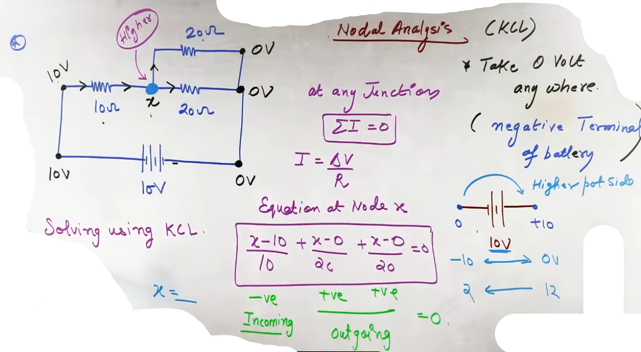
⎚ Symmetry Methods for Resistive Networks

When a circuit is complex but visually repeating or symmetrical, use these shortcuts to simplify it before calculating R_{eq}.
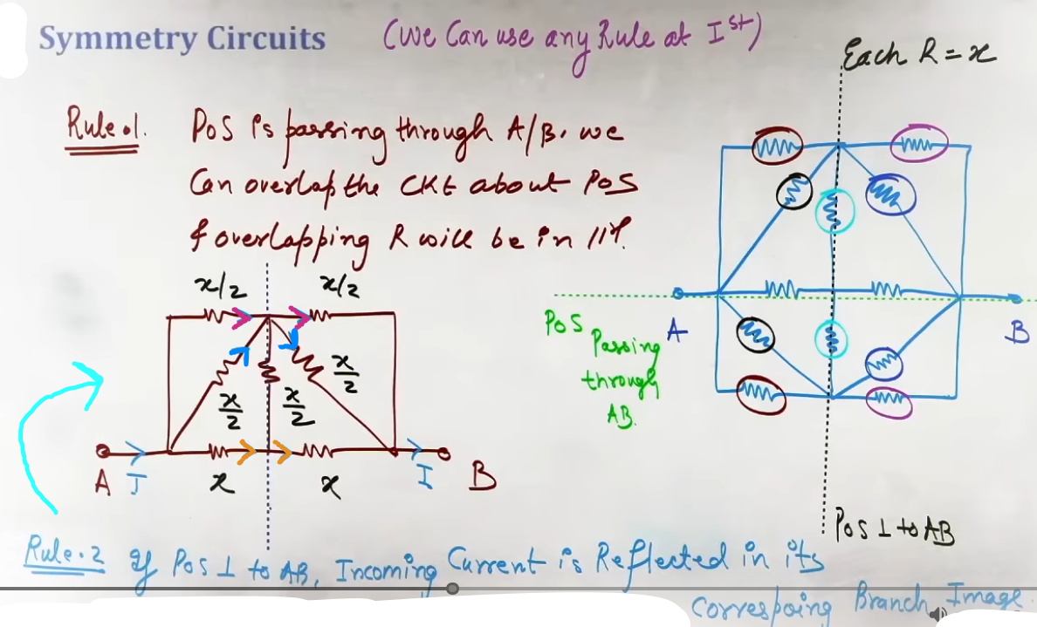

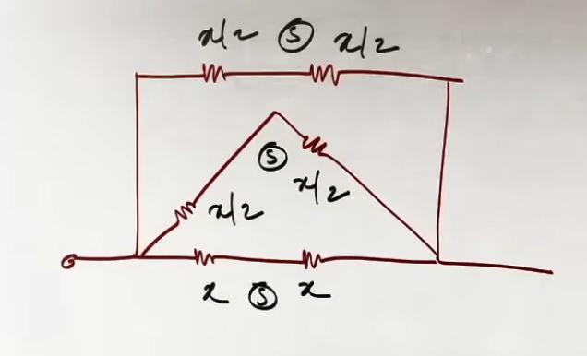

■ Plane of Symmetry (Parallel to the AB axis)
* Action: If you can "fold" the circuit along the axis connecting the two terminals (A and B), overlapping resistors are in parallel.
* Shortcut: Two identical resistors R that overlap upon folding can be replaced by a single resistor of value R/2.

■ Plane of Symmetry (Perpendicular to the AB axis)
* Action: If a symmetry plane cuts through the circuit perpendicular to the path from A to B.
* Insight: The current in an "image" branch on the right must be the same as the current in the corresponding branch on the left.
* Consequence: If no current crosses the symmetry line at a junction, you can ”detach the junction” to simplify the series/parallel combinations.

■ The Cube Formulas (Must-Remember for JEE)
For a cube where every edge has resistance R:
* Across Edge (1-2): R_{eq} = 7/12 R
* Across Face Diagonal (1-3): R_{eq} = 3/4 R
* Across Body Diagonal (1-7): R_{eq} = 5/6 R
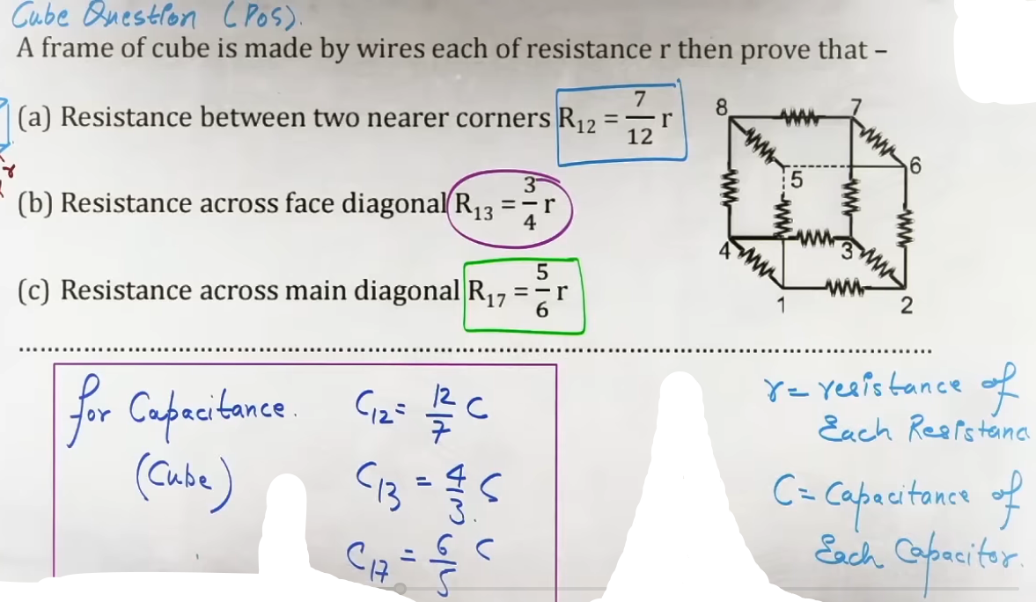

⎚ Cells and Batteries: Real vs. Ideal
■ Core Intuition
* EMF (E): The potential difference across a battery in an ”open circuit” (when no current is drawn). It is the "rated" voltage written on the label.
* Internal Resistance (r): The resistance offered by the chemicals/electrodes inside the cell.
* Terminal Voltage (V): The actual potential available to the external circuit.

# for ideal cell -- (rᵢₙₜₑᵣₙₐₗ = 0)
V(open circuit) = E (EMF)
V(close circuit) = E (EMF)
# for real cell -- (rᵢₙₜₑᵣₙₐₗ != 0)
V(open circuit) = E (EMF)
V(close circuit) = E - I(rᵢₙₜₑᵣₙₐₗ)

■ Detailed Concepts
* Discharging (Normal Use): The battery gives current. V = E - Ir.
* Charging: An external source pushes current *into* the positive terminal. V = E + Ir.
* Condition for V = E: Either the circuit is open (I=0) or the battery is ideal (r=0).

-------------------------------------------------------------------------------
A cell converts chemical energy into electrical energy.
⋅ Electro motive force (E.M.F.)
⋅⋅ EMF depends on :
i) nature of electrolyte
ii) metal of electrodes
⋅⋅ EMF does not depends on :
i) area of plates
ii) distance between the electrodes
iii) quantity of electrolyte
iv) size of cell

⋅ Internal resistance
Resistance offered by the electrolyte of the cell when an electric current flows through it, is known as internal resistance.
⋅⋅ Distance between two electrolytes increases ⇒ r increases
⋅⋅ Area dipped in electrolyte increases ⇒ r decreases
⋅⋅ Concentration of electrolyte increases ⇒ r increases
⋅⋅ Temperature increases ⇒ r decreases
-------------------------------------------------------------------------------

■ Grouping of Cells
* Series: Eₙₑₜ = E_1 ± E_2; rₙₑₜ = r_1 + r_2. (Subtract E if a cell is reversed).
* Parallel (Different Cells): E_{eq}/r_{eq} = E_1/r_1 ± E_2/r_2. If identical cells, E_{eq} = E and r_{eq} = r/n.
* Mixed Grouping (n cells in series, m parallel rows):
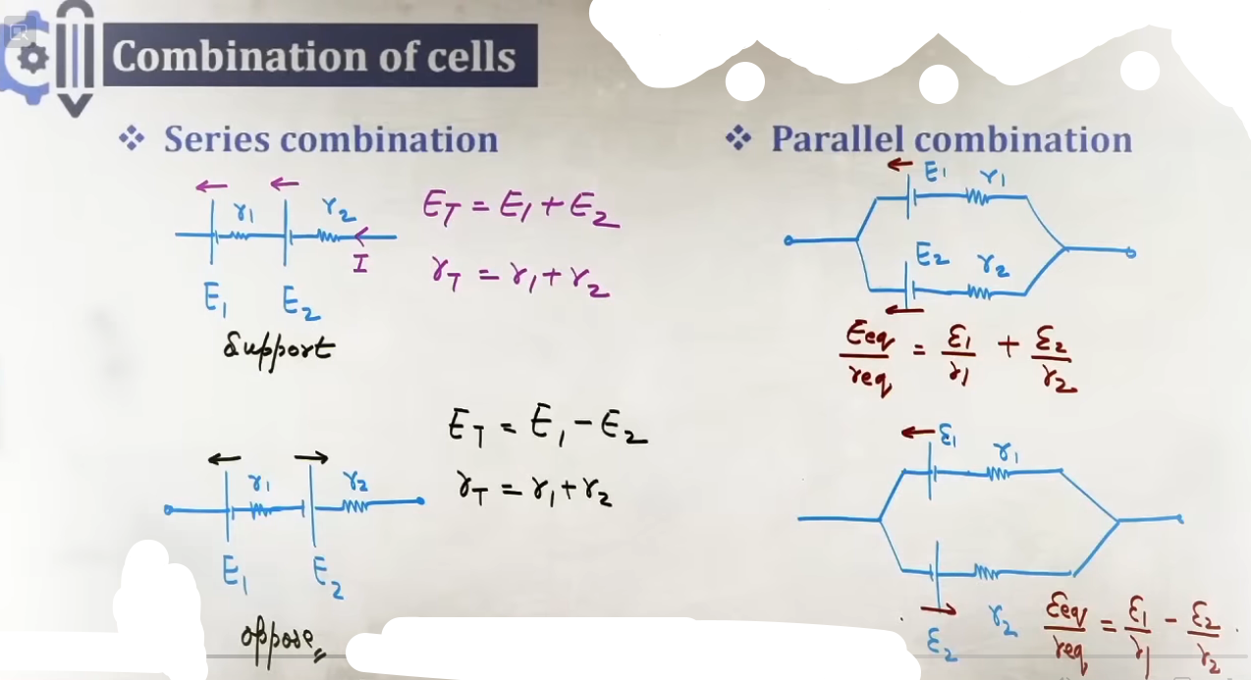
* Maximum Current/Power Condition: Occurs when the External Resistance (R) equals the Total Internal Resistance (nr/m).

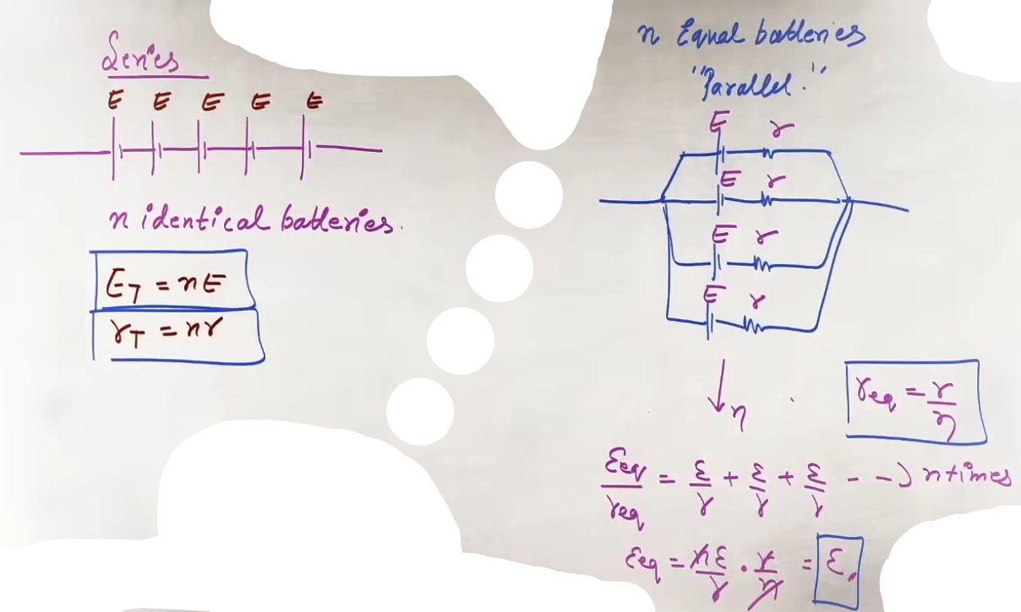

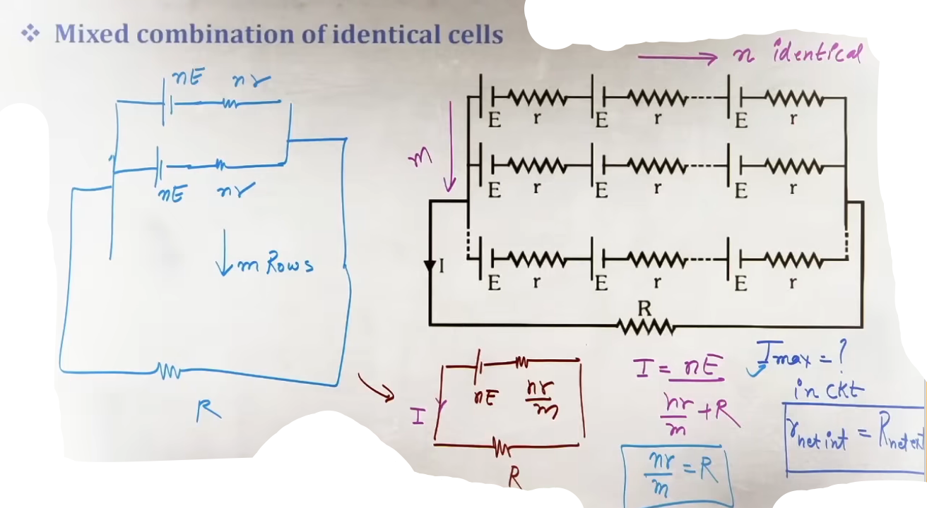

⎚ Measuring Instruments

■ Wheatstone Bridge
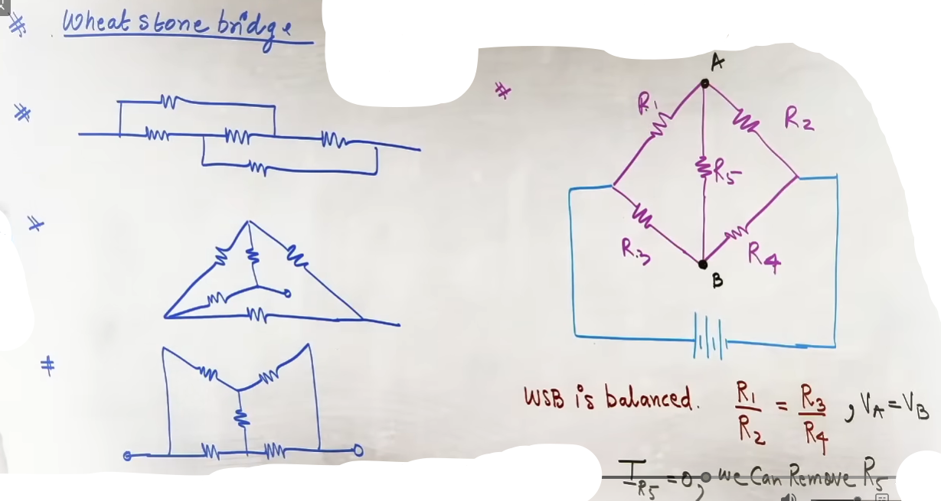
* Principle: A bridge of four resistors.
* Balanced Condition: If R_1/R_2 = R_3/R_4, then the potential at both ends of the central galvanometer is the same (V_G = 0).
* Result: No current flows through the galvanometer (I_G = 0). The central resistor can be removed for calculation.

# If not balanced then use nodal analysis

■ Meter Bridge
* Principle: Practical application of Wheatstone Bridge using a 1-meter wire.
* Formula: R/S = L / (100 - L), where L is the balancing length from the left end.
* End Correction: If the wire doesn't start exactly at 0, add the correction value to L and (100-L) respectively.
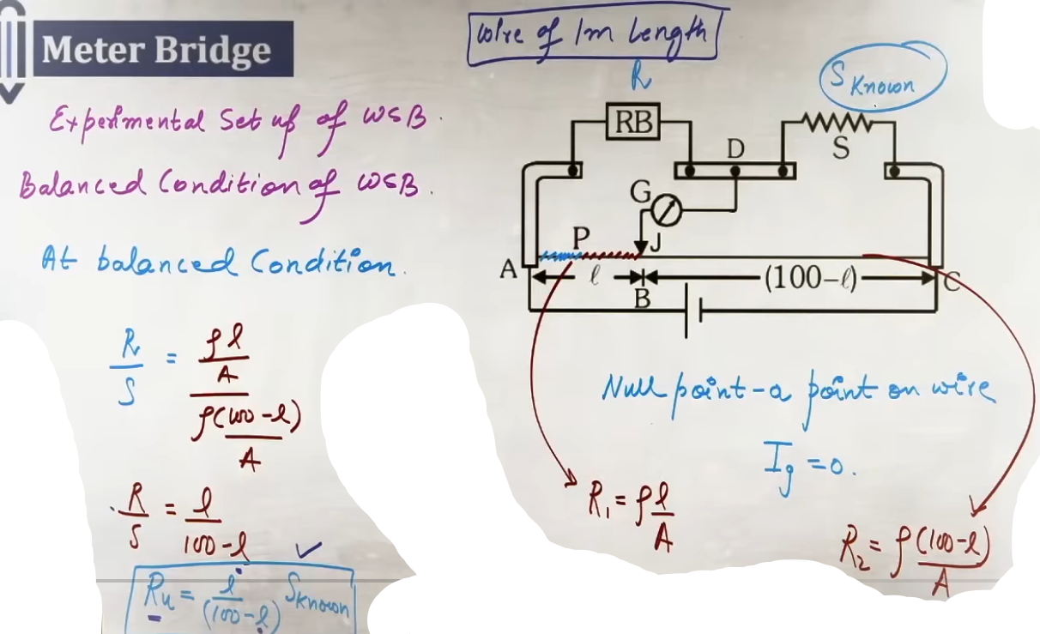
■ Potentiometer (The "Ideal Voltmeter")
Working principal: The potentiometer is based upon the principle that when a contant current is passed through a wire of uniform cross section, the potential drop across any portion of the wire is directly proportional to the length of that portion,

ΔV = IR
ΔV = I(ρL/A)
ΔV/L = Iρ/A
ΔV/L = constant
^_^ k = ΔV/L

* Why it's better: It draws zero current from the circuit being measured at the "null point," providing a perfectly accurate reading.
* Potential Gradient (k): The voltage drop per unit length of the potentiometer wire (k = V_{wire} / L_{wire}).
* Working Principle: At the null point (length l), the unknown EMF is balanced by the potential drop across that length of wire: E = k times l.

⎚ Electrical Power and Heating

■ Detailed Concepts
* Joule’s Heating: H = (I^2)Rt or (V^2)t/R.
OR (BUT ONLY FOR LAST OPTION) H = V/t
* Power (P): P = VI = I^2R = V^2/R.

* Bulb Ratings: A bulb rated "100W, 220V" means it consumes 100W ONLY if connected to exactly 220V.
* Key Step: Always use the rating to find the bulb’s fixed resistance: R = V_{rated}^2 / P_{rated}.
@#
Pₒ (rated) aur Vₒ (rated) diya hoga usse R = (Vₒ^2)/Pₒ lagake risistance nikala fir P = (V^2)/Rₒ (P, V actual circuit ke) use karna h
#@
■ Brightness Rules
* The Golden Rule: Brightness depends on the ”Actual Power Consumed” in the circuit, not the number printed on the bulb.
* In Parallel (Standard Home Wiring): The bulb with higher rated wattage (lower resistance) consumes more power and glows brighter.
* In Series: The bulb with lower rated wattage (higher resistance) consumes more power (I^2R) and glows brighter.

# pehle sare bulbo ko resistor m badal dena h aur phir r_eq se total current nakalna phir current through each resistor nikalna h ya phir voltage se bhi kar sakte h uske bad power through each resistor nikalna h
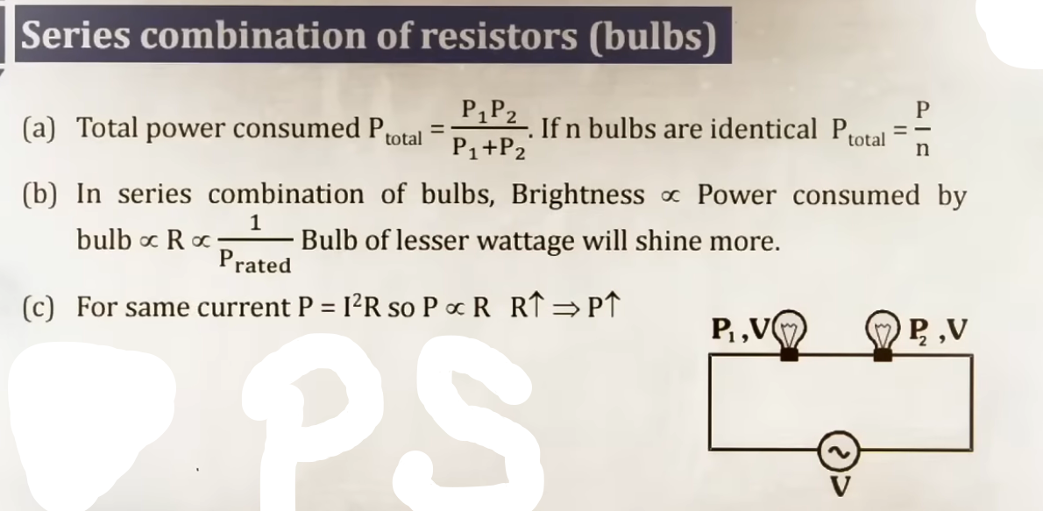
"More power means more brightness"

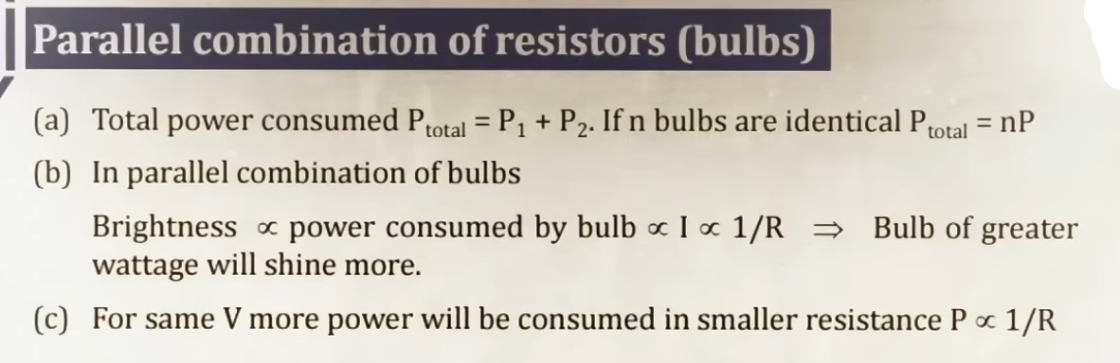

⎚ Common Mistakes & Traps (JEE-Specific)
* Short Circuit Trap: If a zero-resistance wire is in parallel with a resistor, the resistor is "shorted" and removed from calculations. All current takes the wire path.
* Potentiometer Gradient: Forgetting that V_{wire} is not the EMF of the driver battery, but the voltage across the wire after accounting for the driver battery's internal resistance and any series rheostat.
* Bulb Power: Assuming a 100W bulb always consumes 100W. If the voltage is halved, power becomes one-fourth (P = V^2/R).
* Ammeter/Voltmeter Placement: Ammeters must be in series; Voltmeters in parallel. An ideal Ammeter has 0 resistance; an ideal Voltmeter has \infty resistance.

⎚ Final Revision Sheet: High-Yield Results

1. Drift Velocity: v_d = I / (neA).
2. Stretched Wire: If length L → nL, then R → n^2 R.
3. Color Code: BB ROY Great Britain Very Good Wife (Black=0, Brown=1... White=9).
* Gold = 5%, Silver = 10%, No Color = 20% tolerance.
4. KCL/KVL: Charge/Energy conservation.
5. Potentiometer: E_1/E_2 = l_1/l_2 (Comparison of EMFs).
6. Internal Resistance via Potentiometer: r = R \cdot (\frac{l_1}{l_2} - 1).
7. Max Power Transfer: External R = Total Internal r.

